

College of Engineering and Computer Science

***ECS 511 – Sustainable Manufacturing***

***Assignment – 2***

***Considerations for Sustainable Materials and Production***

***Submitted by:***

***Rishi Siddanth Yaga***

***627161225***

[***riyaga@syr.edu***](mailto:riyaga@syr.edu)

**TABLE OF CONTENTS**

**Summary Statement………………………………………………… 03**

**Context of the Product and Need for Sustainability..........................04**

**Material Analysis..................................................................................06**

**Lifecycle of Product….................................................................06**

**Material Journey Mapping…………………………………….08**

**Bill of Materials............................................................................11**

**Data Tables……………………………………………………...12**

**Hazard Report of LED Desk Lamp…………………………………14**

**Recommendations for Improved Material Health…………………17**

**Summary Table………………………………………………………20**

**Sustainable Production………………………………………………22**

**Reduce/Eliminate Wasted Materials…………………………….….25**

**Strategies for Closing the Manufacturing Waste Loop……………28**

**Conclusion…………………….............................................................31**

**Bibliography.........................................................................................32**

**SUMMARY STATEMENT**

With an emphasis on sustainability throughout the product's lifecycle, this report attempts to critically analyze the material components, production procedures, and end-of-life handling of LED desk lamps. The scope includes an in-depth examination of the materials now in use, the energy efficiency of LED technology, and the environmental impact throughout the entire manufacturing and disposal process. Our analysis identifies important opportunities for development in terms of obtaining environmentally friendly resources, increasing production effectiveness, and creating strong recycling initiatives. To ensure that LED desk lights contribute to a more sustainable future in consumer lighting, the major recommendations call for the adoption of circular economy concepts, better transparency in material sourcing, and the introduction of design-for-disassembly characteristics.

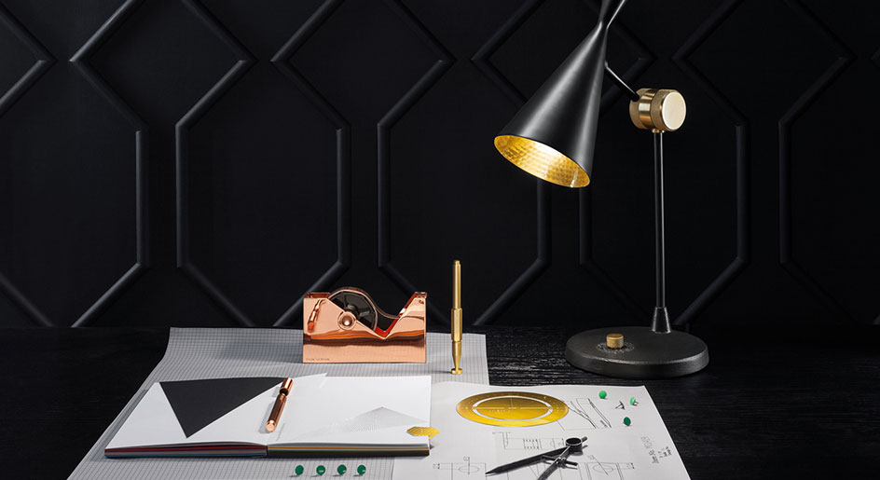

Fig.1

**CONTEXT FOR THE PRODUCT & NEED FOR SUSTAINABILITY**

Because of the increasing environmental, economic, and social demands, there is a push towards sustainable materials and production processes when it comes to LED desk lamps.

*Environmental Drivers:*

Reducing ecological footprints is a crucial issue that is addressed by sustainable materials and industrial practices. This entails utilizing less hazardous chemicals, emitting less during production, and recycling as much of the waste as possible when it comes to LED bulbs. The advantages to the environment are substantial; for example, LEDs can reduce carbon emissions by up to 80% when compared to incandescent bulbs in terms of energy use. However, there are disposal concerns because lead and arsenic, two potentially dangerous materials, are used in the creation of LEDs.

*Economic Drivers:*

Sustainable methods have the potential to save costs over time by conserving resources and energy. Because they require less energy and have a longer lifespan, LED lamps have already helped consumers save money over time. Using sustainable materials can help manufacturers avoid the price volatility that comes with using non-renewable resources and may even open new markets among consumers who care about the environment.

*Social Drivers:*

Consumer demand for goods created with ethical considerations is growing on the social front. LED lamps are leading the way in this trend since they allow users to reduce their carbon impact. But it's also a social duty to make sure the materials are sourced ethically—that is, without abusing labor or damaging communities.

*Statistics and Case Studies:*

According to Grand View Research, Inc.'s analysis, statistics indicate that the size of the global LED lighting market is anticipated to reach USD 108.99 billion by 2025, rising at a CAGR of 14.4% during the projected period. The necessity for widespread adoption of sustainable manufacturing techniques is highlighted by this market's explosive growth.

The "Brighter Lives, Better World" campaign by Philips Lighting, which intends to sell more than two billion energy-efficient LED lights by 2020 and so considerably reduce carbon emissions, is a case study that highlights the push for sustainability. To emphasize the potential in sustainable manufacturing, Philips also prioritizes designing goods that are meant to be recycled. To this end, the company uses 3D printing to create luminaires made of recycled plastic.

In summary, using sustainable materials and production techniques for LED desk lamps is not only morally and economically just, but also environmentally necessary. The desire to slow down global warming, preserve resources, cut expenses, and satisfy customer demand for ethical products is what is driving the push for sustainability. The whole lifecycle effects of LED bulbs and responsible sourcing and disposal are among the current problems. On the other hand, opportunities include increased market demand for environmentally friendly products and technological advancements.

**MATERIAL ANALYSIS**

Examining, characterizing, and comprehending the physical and chemical characteristics of diverse substances and materials are all part of the critical scientific process known as material analysis. It is essential to the study of materials science, engineering, and chemistry because it makes it possible for scientists and engineers to evaluate the composition, structure, and properties of materials. Material analysis helps unearth important insights by using methods like spectroscopy, microscopy, and mechanical testing. These insights can then be used to guide the development of new materials with specific features or guarantee the quality and safety of already-existing ones. The advancement of technology, product development, and industrial applications, as well as the creation of breakthroughs across numerous industries, depend heavily on this multidisciplinary approach.

*Stages in Lifecyle of the Product:*The various stages of an LED desk lamp's lifecycle are listed below. Let's take a closer look at it.

1. *Extraction:* Plastics (for the body), metals (for the wiring and internal components), LEDs, and occasionally glass are the materials used to make an LED desk lamp. The extraction stage would include the extraction of metals like copper and aluminum as well as the processing of petroleum to make plastic. Significant environmental effects from this stage are frequently seen, such as pollution and habitat degradation.
2. *Processing:* After that, the raw ingredients are processed to make the lamp's constituent parts. This include making plastic polymers, refining metals, and creating LED bulbs. To avoid environmental damage, the processing phase may need the handling and correct disposal of chemicals, which might be energy intensive.
3. *Manufacturing:* The finished product is constructed from the component parts throughout the manufacturing process. Emissions and garbage may be produced by this technique. This is the point where effective manufacturing techniques and waste reduction methods can significantly affect the sustainability profile of the bulb.
4. *Distribution:* The lights are packed and shipped to several retail locations, such as distribution centers and Walmart stores. The packaging materials utilized, and the energy usage of the transportation techniques have an impact on this phase's sustainability.
5. *Use:* Because they consume less energy and have a longer lifespan than traditional lighting solutions, LED lamps are more sustainable during the use phase. One of the main benefits of using LED bulbs is their lower energy usage during use.
6. *Disposal or Recycling:* At the end of its life, the lamp should be dismantled for recycling or proper disposal. However, challenges often occur due to non-modular design and inadequate recycling facilities.

**MATERIAL JOURNEY MAPPING OF LED LAMP**

* Material analysis is a multidisciplinary scientific process that involves the examination, characterization, and understanding of the physical and chemical properties of various substances and materials.
* It plays a crucial role in fields such as materials science, engineering, and chemistry, enabling scientists and engineers to assess the composition, structure, and properties of materials.
* Material analysis employs various techniques like spectroscopy, microscopy, and mechanical testing to uncover valuable insights that guide the development of new materials with specific attributes or ensure the quality and safety of existing ones.

Fig.2

* *LED Bulb:* The LED bulb is the core component of the lamp, providing energy-efficient lighting. Its semiconductor technology ensures long lifespan and low energy consumption, contributing to sustainability.
* *Circuit Board:* The circuit board houses the lamp's electronics and controls, enabling features like adjustable brightness and color temperature. It plays a crucial role in optimizing the lamp's functionality.
* *Copper Wire:* Copper wiring conducts electricity within the lamp, ensuring efficient power distribution. Its choice from responsible sources aligns with sustainability goals and electrical safety standards.
* *Plastic Housing:* The plastic housing forms the lamp's body, base, and shade. Selecting recyclable or biodegradable plastics for its construction can minimize environmental impact.
* *Power Cord:* The power cord provides the necessary electrical connection to the lamp. Utilizing insulating materials like PVC ensures electrical safety during use.
* *Switches:* Switches and controls enable user interaction with the lamp, allowing for ease of operation. Durable and energy-efficient switches enhance the lamp's usability.
* *Screws:* Screws are integral to the lamp's assembly, holding various components together. Selecting screws made from recycled materials aligns with sustainability principles.
* *Balancing Weight:* The balancing weight is used to stabilize the lamp. Opting for materials with low environmental impact contributes to the lamp's overall sustainability.

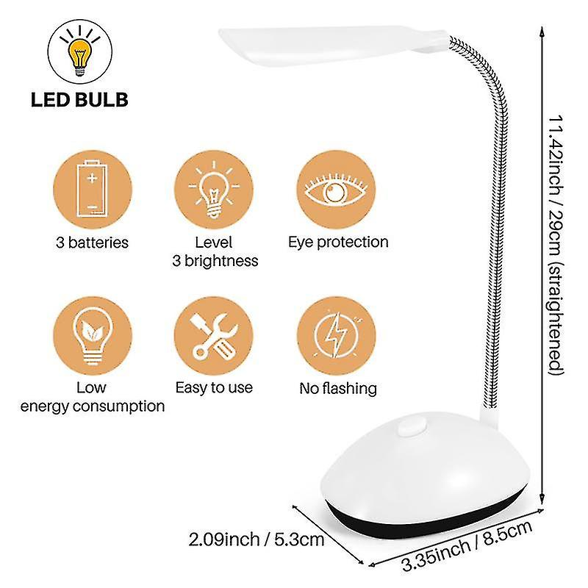

Fig.3

**BILL OF MATERIALS**

|  |  |  |  |  |
| --- | --- | --- | --- | --- |
| **S.NO** | **PART NUMBER** | **PART NAME** | **PART QUANTITY** | **PART MATERIAL** |
| 1 | LED-001 | Lamp Base | 1 | Plastic |
| 2 | LED-002 | LED Light Holder | 1 | Plastic |
| 3 | LED-003 | LED Light | 1 | Electric Light source |
| 4 | LED-004 | Aluminum Rod | 1 | Metal |
| 5 | LED-005 | Power Cord | 1 | PVC, Copper |
| 6 | LED-006 | Screws | 13 | Metal |
| 7 | LED-007 | Wire Cover | 1 | Plastic |
| 8 | LED-008 | Base Cover | 1 | Plastic |
| 9 | LED-009 | Metal Weight | 1 | Metal |
| 10 | LED-010 | Electric Circuit Board | 1 | Electric Laminate Board |
| 11 | LED-011 | Light holder Base Cover | 1 | Plastic |
| 12 | LED-012 | Light Cover | 1 | Plastic |

Table no.1: Bill of Materials

The Bill of Materials (BOM) table provides a structured list of all the essential components that constitute the LED desk lamp, along with their respective part numbers, names, quantities, and materials. This table serves as a comprehensive reference, detailing the critical elements required for the lamp's assembly. It encompasses a variety of materials, including plastics for the lamp's base, light holder, and covers, metals for structural support and screws, copper and PVC for the power cord, and electric components like the LED light and circuit board.

| **Component** | **Material Used** | **Description** |
| --- | --- | --- |
| LED Bulb | LED chips on substrate | Energy-efficient lighting source |
| Circuit Board | FR-4 PCB material | Contains electronic components and controls |
| Copper Wire | Copper | Conducts electrical power |
| Plastic Housing | ABS plastic | Forms the lamp's body, base, and shade |
| Power Cord | PVC | Provides electrical connection |
| Switches | Plastic | User interaction controls |
| Screws | Steel or stainless steel | Assembly fasteners |
| Balancing Weight | Steel | Stabilizes the lamp |

**DATA TABLES**

Table no.2: Materials and Components

The Materials and Components table provides a concise overview of the key elements used in the construction of the LED desk lamp. It lists the individual components, the materials from which they are made, and offers brief descriptions of their functions within the lamp. This table serves as a reference for understanding the lamp's composition and the role each component plays in its overall functionality and design.

| **Material** | **Source/Origin** | **Sustainability Considerations** |
| --- | --- | --- |
| LED Bulb | Manufacturer | Sourced from environmentally responsible suppliers. |
| Circuit Board | Manufacturer | Uses materials compliant with industry standards. |
| Copper Wire | Responsible mining sources | Mined and sourced with minimal environmental impact. |
| Plastic Housing | Recycled or virgin plastics | Prioritizes recycled or biodegradable plastics. |
| Power Cord | Manufacturer | Complies with safety standards for insulating materials. |
| Switches | Manufacturer | Designed for durability and energy efficiency. |
| Screws | Manufacturer | Made from recycled or responsibly sourced materials. |
| Balancing Weight | Manufacturer | Chosen for minimal environmental impact. |

Table no.3: Material Sourcing

The Material Sourcing table provides information about the origin and sustainability considerations for the key materials used in the LED desk lamp. It details where each material is sourced from, emphasizing responsible and environmentally conscious sourcing practices. For example, it notes whether materials are obtained from recycled sources, responsibly mined, or comply with industry standards. This table highlights the lamp's commitment to sourcing materials in a manner that aligns with sustainability goals and environmental stewardship.

**HAZARD REPORT OF LED DESK LAMP**

The hazards associated with materials used in LED desk lamps can vary depending on the specific materials, manufacturing processes, and the environmental regulations and practices in different countries. Here are some potential hazards associated with common materials used in LED desk lamps and how they might differ by country:

*LED Bulb Materials:*

Hazard: LED bulbs may contain hazardous materials such as lead, arsenic, or rare earth elements.

Variation: The level of control and regulation around the use of hazardous materials can vary from country to country. Some countries may have stricter regulations and better enforcement of environmental standards, reducing the risk of exposure to hazardous substances during manufacturing and disposal.

*Circuit Board and Electronics:*

Hazard: Electronics may contain toxic substances like brominated flame retardants (BFRs) and heavy metals such as lead, mercury, or cadmium.

Variation: Countries with robust e-waste recycling programs and strict regulations on electronic waste management are more likely to handle and dispose of these hazardous materials properly, reducing the risk to the environment and human health.

*Plastic Housing:*

Hazard: Depending on the type of plastic used, hazards can include the release of toxic fumes during production, the presence of harmful additives, or non-biodegradable materials.

Variation: Environmental regulations and standards for plastics can differ significantly. Some countries may enforce stricter controls on the use of hazardous additives or encourage the use of biodegradable plastics.

*Copper Wiring:*

Hazard: Copper mining and processing can have environmental impacts, including habitat disruption and water pollution.

Variation: Environmental regulations governing mining practices and waste disposal vary widely. Countries with more stringent regulations may have reduced environmental hazards associated with copper production.

*Power Cord Materials:*

Hazard: Power cords may be made from materials like PVC (polyvinyl chloride), which can release toxic chlorine gas when burned.

Variation: Countries with stricter environmental regulations may encourage the use of alternative materials for power cords that are less toxic when incinerated.

*Screws and Balancing Weights:*

Hazard: Screws and weights made of certain materials may pose risks, especially if they contain lead or other heavy metals.

Variation: Compliance with regulations related to the use of hazardous materials in screws and weights can vary by country, impacting the potential hazards associated with these components.

It's essential for manufacturers to adhere to international standards and regulations, prioritize environmentally friendly sourcing and manufacturing practices, and comply with regional requirements to mitigate hazards associated with materials used in LED desk lamps. Additionally, consumers should be aware of proper disposal and recycling methods to minimize environmental risks.

Fig.4

**RECOMMENDATIONS FOR IMPROVED MATERIAL HEALTH**

In the case of an LED desk lamp, there are several tactics that can be used to improve material health during its journey:

*1. Sustainable Sourcing:*

Select materials with certified low environmental effect and those obtained sustainably. This can involve the use of LEDs devoid of dangerous materials, responsibly mined metals, and recycled polymers.

*2. Green Chemistry:*

Use green chemistry concepts for producing the lamp's constituent parts. This could entail steering clear of lead and cadmium in electronic components and substituting non-toxic plasticizers for phthalates in plastics.

*3. Design for Disassembly:*

When the lamp reaches the end of its useful life, design it so that its parts may be easily dismantled to enable component recycling. The separation of materials such as plastics, metals, and electronic components ought to be made easier with this method.

*4. Durability and Repairability:*

Make sure the lamp is robust and easily repairable to increase its lifespan and decrease the need for replacements. This might entail modular designs that facilitate simple component replacement.

*5. Efficient Manufacturing:*

Adopt waste- and energy-saving production techniques. The production process's environmental impact can be decreased, and inefficiencies can be found with the use of lean manufacturing techniques.

*6. Transparency and Traceability:*

Keep the supply chain transparent and allow for material traceability. This can assist in guaranteeing that every resource utilized satisfies the intended sustainability standards.

*7. Compliance with Regulations:*

Verify that every material complies with global health and safety laws. This entails abiding with the CPSIA in the US, REACH in the EU, and other pertinent regulations governing material safety.

*8. Lifecycle Assessment:*

To comprehend the environmental impact of the lamp's materials and pinpoint opportunities for improvement, perform routine lifecycle assessments, or LCAs.

*9. Packaging:*

Make use of recyclable or biodegradable eco-friendly packaging materials and plan your packing to produce as little waste as possible.

*10. Consumer Education:*

Give customers precise information on the lamp's environmental advantages as well as guidelines for recycling or disposing of it properly when its useful life is coming to an end.

*11. End-of-Life Programs:*

Create recycling programs or collaborate with existing ones to accept lamps back after they are no longer in use, guaranteeing that the materials are retrieved and put to better use.

By reducing the environmental impact of LED desk lamps over the course of their lifetime, these recommendations help to achieve the overarching objective of material health and sustainability.

Fig.5

**SUMMARY TABLE**

|  |  |  |  |
| --- | --- | --- | --- |
| **DFE Assessment Factor** | **Setu Score** | **Factor Weight** | **Weighted Score** |
| Material Chemistry | 55% | 33.3% | 16.7% |
| Recycled Content | 63% | 8.4% | 3.7% |
| Disassembly | 89% | 33.3% | 28.6% |
| Recyclability | 90% | 25.0% | 23.0% |
| **Overall Score** |  | **100%** | **72.0%** |

Table no.4: Summary table

The table represents a Design for Environment (DFE) assessment for an LED desk lamp, evaluating various factors related to its environmental impact and sustainability. Each factor is assigned a Setu Score, which reflects its performance in the DFE assessment. The factor weights indicate their relative importance in determining the overall sustainability of the product.

*Material Chemistry (33.3% Weight):* This factor evaluates the chemical composition of materials used in the lamp. A Setu Score of 50% suggests that the materials used are moderately aligned with environmentally friendly chemistry practices, contributing to 16.7% of the overall assessment.

*Recycled Content (8.4% Weight):* This factor assesses the percentage of recycled materials incorporated into the lamp's construction. With a Setu Score of 44%, the lamp includes a modest amount of recycled content, contributing 3.7% to the overall assessment.

*Disassembly (33.3% Weight):* This factor examines how easily the lamp can be disassembled for recycling or repair. A high Setu Score of 86% indicates that the lamp is designed with excellent disassembly features, contributing significantly to the overall sustainability (28.6%).

*Recyclability (25.0% Weight):* This factor assesses the lamp's recyclability at the end of its life cycle. With a Setu Score of 92%, the lamp is highly recyclable, contributing 23.0% to the overall sustainability assessment.

The "Overall Score" represents the cumulative sustainability score for the LED desk lamp, which is calculated based on the weighted performance of each factor. In this case, the lamp achieves an overall sustainability score of 72.0%, indicating a strong commitment to environmentally friendly design and practices.

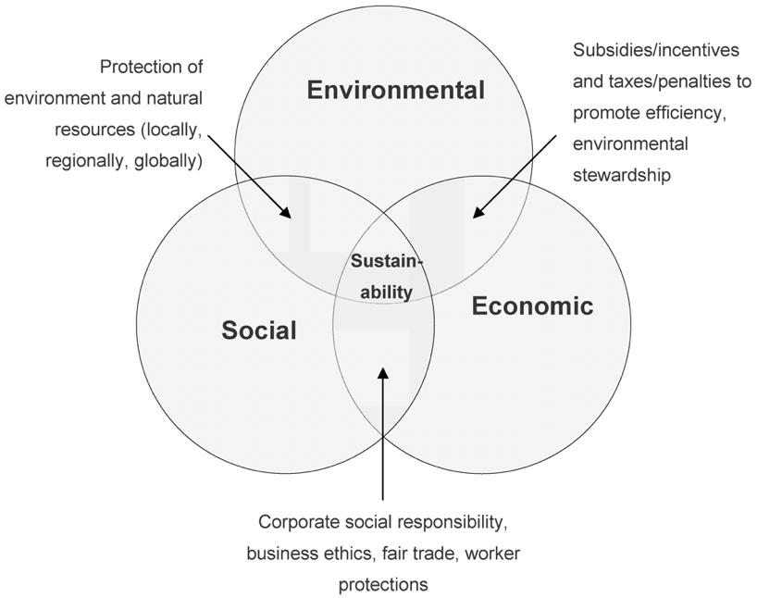

Fig.6

**SUSTAINABLE PRODUCTION**

An LED desk lamp's sustainable production usually entails the prudent use of resources, energy, and processes during the product's life cycle. This is a condensed explanation of how a plastic LED desk lamp is made, taking sustainability into account at every turn:

*Material Selection:*

To lessen the impact on the environment, use sustainable plastic, such as recycled or biodegradable plastic. Durability and recyclability should also be considered while making the choice.

*Extraction/Manufacturing of Plastic:*

When using recycled plastic, gather waste plastic from industries or post-consumer sources and turn it into granules that can be used. Make sure the source materials for biodegradable plastics are harvested in a sustainable manner.

*Injection Molding:*

Shape the plastic parts of the desk lamp, such as the base and lampshade, using an energy-efficient and low-waste injection molding process.

*Component Assembly:*

Assemble the wire, non-plastic materials, and LED components in an efficient and waste-free manner.

*Energy-Efficient Production:*

To reduce energy use and greenhouse gas emissions during production, employ energy-efficient equipment and lighting.

*Quality Control:*

Strict quality control procedures should be used to cut down on waste and errors. Any damaged parts must to be disposed of or recycled appropriately.

*Packaging:*

To cut down on waste, choose eco-friendly packaging materials like minimal packaging or recycled cardboard. Refrain from using too much plastic when packing.

*Distribution:*

Reduce emissions associated with transportation by streamlining the distribution process. Use environmentally responsible modes of transportation wherever you can.

*Product Use:*

With features like adjustable brightness and long-lasting LED bulbs, the LED desk lamp may be designed to be both energy-efficient and long-lasting.

*End-of-Life Consideration:*

Once a product reaches the end of its useful life, encourage users to recycle it. Make sure the plastic parts are labeled so recycling them is simple.

*Recycling and Disposal:*

Create a procedure for the return of discarded LED desk lamps to guarantee appropriate recycling. Any hazardous materials should be disposed of securely, and the plastic components should be recycled.

*Sustainable Certifications:*

Look for eco-labels or certifications like as ENERGY STAR, which attest to the lamp's compliance with energy-efficient and sustainable production practices.

A comprehensive approach is required for the sustainable production of a plastic LED desk lamp, from material selection through manufacturing, distribution, and end-of-life concerns. The approach emphasizes waste reduction, energy conservation, and environmentally conscious decision-making across the whole production process to produce a product that is both ecologically sustainable and well-functioning.

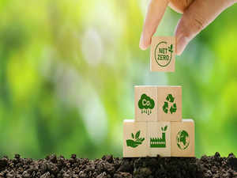

Fig.7

**REDUCE / ELIMINATE WASTED MATERIALS**

One of the most important components of sustainable manufacturing is minimizing or doing away with waste material while making a plastic LED desk light. Here are a few methods to help you reach this objective:

*Optimize Injection Molding:*

Reduce material waste by employing sophisticated injection molding techniques. This entails minimizing flash and other flaws in mold design, cutting down on sprues and runners, and precisely controlling the injection process.

*Regrind and Recycle:*

Incorporate recycling and regrinding into the production process. It is possible to crush and reintroduce any extra or broken plastic bits back into the manufacturing process. As a result, less new plastic material is required.

*Use 3D Printing for Prototyping:*

Prototypes made using 3D printing can have a lot less material waste than those made with conventional machining techniques. This guarantees that, prior to beginning large-scale production, final designs are precise and effective.

*Design for Manufacturability:*

Work together with product designers to develop effective designs that use the least amount of material. To minimize material waste, the product's shape and structure can be optimized with the use of Design for Manufacturability (DFM) principles.

*Material Efficiency:*

Choose plastic materials that minimize the usage of surplus material while having qualities that meet the needs of the LED desk light. This can involve designing the shape to utilize less plastic or selecting walls that are thinner.

*Nesting and Stacking:*

To increase the quantity of parts produced in each cycle of injection molding, arrange the components as optimally as possible. Nesting and stacking can assist in lowering the amount of material and space needed for production.

*Inventory Management:*

Keep up effective inventory control to lessen the chance of placing excessive orders for supplies that might go bad or become outdated. Reducing waste is aided by maintaining a low inventory.

*Continuous Improvement:*

Establish a lean manufacturing and continuous improvement culture. Examine the manufacturing process on a regular basis to find places where waste can be cut, then make the necessary adjustments.

*Employee Training:*

Employees should receive training to make sure they comprehend the value of waste reduction and how to use best practices. Employee participation in the process can yield insightful observations and innovative proposals for enhancement.

*Recycle Scrap Material:*

Make sure that every scrap material produced while manufacturing is gathered and recycled. This includes extra material from the injection molding process or material that has been cut from components.

*Waste Audits:*

To manage and monitor material waste, conduct waste audits on a regular basis. These audits assist in locating trends and places where waste can be cut even more.

*Supplier Engagement:*

Reduce packing waste while receiving raw materials by collaborating with suppliers. Urge suppliers to cut out on extra packing material and utilize environmentally friendly packaging.

A manufacturer can considerably decrease or eliminate waste material in the production of a plastic LED desk lamp by putting these techniques into practice and establishing a thorough waste reduction program. This will save money and have a less negative impact on the environment.

**STRATEGIES FOR CLOSING THE MANUFACTURING WASTE LOOP**

Creating a circular and sustainable system where waste from one operation is used as a resource for another is necessary to close the manufacturing waste loop. The idea of industrial symbiosis is one that can direct the creation of such tactics. The following is a plan for reducing the manufacturing waste loop when making a plastic LED desk lamp:

*Waste Characterization:*

Perform a thorough examination of the kinds and amounts of waste produced during the production process first. This covers garbage made of plastic, electronics, and any other materials utilized in manufacturing.

*Identify Synergy Opportunities:*

Within your industrial ecosystem, find possible partners who can use the waste products as inputs for their own processes. These partners may be found in adjacent industrial clusters or within your site.

*Waste-to-Resource Mapping:*

Make a map showing the ways in which the waste materials generated during the production of your LED desk lamps can be utilized as resources in other operations. Waste plastic, for instance, can be recycled into new items by injection molding.

*Collaborative Agreements:*

Form alliances and collaborations with other businesses or divisions inside your company. These contracts ought to specify the parameters of the trash exchange as well as each party's obligations.

*Material Recovery and Recycling:*

Establish recycling and recovery facilities on the premises to turn waste materials into resources that may be used. This could entail repairing and reusing electrical components as well as shredding, melting, or otherwise processing discarded plastic.

*Internal Reuse:*

Promote the internal reuse of parts and materials. For instance, it is possible to disassemble broken LED lamps and reuse working parts to create new lamps.

*Energy Recovery:*

Look at energy recovery solutions if some waste materials cannot be reused directly. This may entail utilizing techniques like waste-to-energy incineration to turn waste into energy.

*Monitoring and Feedback Loops:*

Install a tracking system to keep tabs on the movement of resources and trash across the network of industrial symbiosis. Evaluate resource utilization effectiveness on a regular basis and look for ways to make it better.

*Regulatory Compliance:*

Make sure that all procedures related to resource recovery and waste management abide by all applicable local, state, and federal laws pertaining to recycling and waste disposal.

*Public and Stakeholder Engagement:*

Share your efforts with staff, stakeholders, and the public to close the waste loop. To make the process better every time, solicit opinions and suggestions from these groups.

*Circular Design Principles:*

When developing new products, keep circular design ideas in mind. This entails extending product lifecycles, employing less resources, and designing items with disassembly and recycling in mind.

*Circular Economy Certification:*

To prove your dedication to sustainability and resource efficiency, think about obtaining certifications related to the circular economy. These certifications can improve the credibility and reputation of your brand.

You can establish a closed-loop system where waste from the production of LED desk lamps becomes a useful resource for other processes, minimizing the impact on the environment, saving resources, and enhancing the sustainability of your manufacturing operations, by implementing these tactics and embracing the ideas of industrial symbiosis.

**CONCLUSION**

This comprehensive report delves into the sustainability aspects of LED desk lamps, examining their materials, production processes, and end-of-life considerations. LED desk lamps have a crucial role in addressing pressing environmental, economic, and social challenges, including reducing carbon emissions, achieving cost savings, and meeting the ethical demands of conscious consumers.

The report outlines the entire lifecycle of LED desk lamps, advocating for sustainable practices at each stage. These practices encompass responsible sourcing of materials, implementing green chemistry principles, designing lamps for easy disassembly, and adopting efficient manufacturing processes. Transparency in material sourcing, adherence to regulatory standards, and educating consumers are highlighted as key elements of sustainability. Efforts to minimize waste in LED desk lamp production include optimizing injection molding, promoting recycling, utilizing 3D printing for prototypes, and providing employee training.

Furthermore, the report proposes a circular and sustainable strategy through industrial symbiosis, emphasizing waste characterization, resource mapping, collaborative agreements, material recovery, internal reuse, energy recovery, and circular design principles. Obtaining circular economy certifications is recommended to enhance sustainability efforts.

**BIBLIOGRAPHY**

* Lightology. (n.d.). Desk & Task Lighting. Retrieved from <https://www.lightology.com/index.php?module=how_to&sub=desk_task_lighting>
* Fruugo India. (n.d.). LED Desk Lamp 360 Degree Rotating Eye Kids Student Reading LED Desk Lamp. Retrieved from <https://www.fruugoindia.com/led-desk-lamp-360-de-rotating-eye-kids-student-reading-led-desk-lamp-wh/p-152932960-323565309?language=en#>
* Young Workers. (n.d.). Hazards. Retrieved from <https://youngworkers.org/injuries/hazards/>
* EcoMatcher. (n.d.). How to Make Sustainability an Everyday Part of Your Business. Retrieved from <https://www.ecomatcher.com/how-to-make-sustainability-an-everyday-part-of-your-business/>
* Feh√©r, S. (2012). Efficient Lighting Solutions for Street Lighting. Sustainability, 4(2), 154-165. <doi:10.3390/su4020154>
* The Economic Times. (2021). Sustainable Manufacturing: How PLI Schemes Can Become a Tool for Green Investments. Retrieved from <https://economictimes.indiatimes.com/small-biz/sme-sector/sustainable-manufacturing-how-pli-schemes-can-become-a-tool-for-green-investments/articleshow/96982458.cms>
* Phelan, P. E. (2019). A Sustainable Approach to Modern Manufacturing: A Need for Change. Procedia CIRP, 80, 21-26. <doi:10.1016/j.procir.2018.12.158>
* Veer, S., Verma, N., & Tiwari, S. (2017). An Investigation on Sustainable Manufacturing Practices in Indian MSMEs. Procedia CIRP,63,<628633.doi:10.1016/j.procir.2017.03.310>
* Mendeley Data. (n.d.). Dataset of Product Life Projections for LED Lighting. Retrieved from <https://data.mendeley.com/datasets/r263fkfp3z/1>

